www.iheem.org.uk Version 1.0 April 2020
IHEEM Oxygen Gas Capacity Assessment Tool
DISCLAIMER: This information and template is provided for guidance purposes only to assist in these unprecedented Covid-19 requirements and should not be regarded as a substitute for normal good working practice, local regulations, and advice. The template refers to the Department of Health (England) recommended diversified flow guidelines. You should not rely upon the information as your only basis for making business, legal or other decisions. Any reliance you place on such material is at your own risk.
____________________________________________________________________________________________________
About the Tool
This template allows the Hospital to understand their current exposure and explore potential COVID-19 scenarios. Incorporating design parameters used in a variety of hospitals including the Nightingale Field hospitals in the UK to assess the likely demand for Oxygen in hospitals with in-patient facilities for COVID-19. The template sets out recommended diversified flow levels for COVID-19 areas as defined by the Critical Care National Medical Director, the templates allows manipulation of the quantity of ventilators in use or potential alternative care models.
The template provides the ability to model different scenarios to assess the Oxygen demand. The ability of a VIE to deliver its rated flow rate is dependent on a number of factors that are outside the scope of this assessment e.g. the age and condition of the distribution pipework, complexity, length and pipe sizing of the distribution pipework etc.
How the Tool Works
The Tool is driven by a series of Macro’s and therefore on load YOU MUST ENABLE MACROS when prompted by Excel.
comprises of a two key tabs INSTRUCTIONS and OVERVIEW and is driven by a hidden base template tab [Template DO NOT USE] which are located at the bottom of this workbook:
To start please click on the OVERVIEW Tab at the bottom of the page.

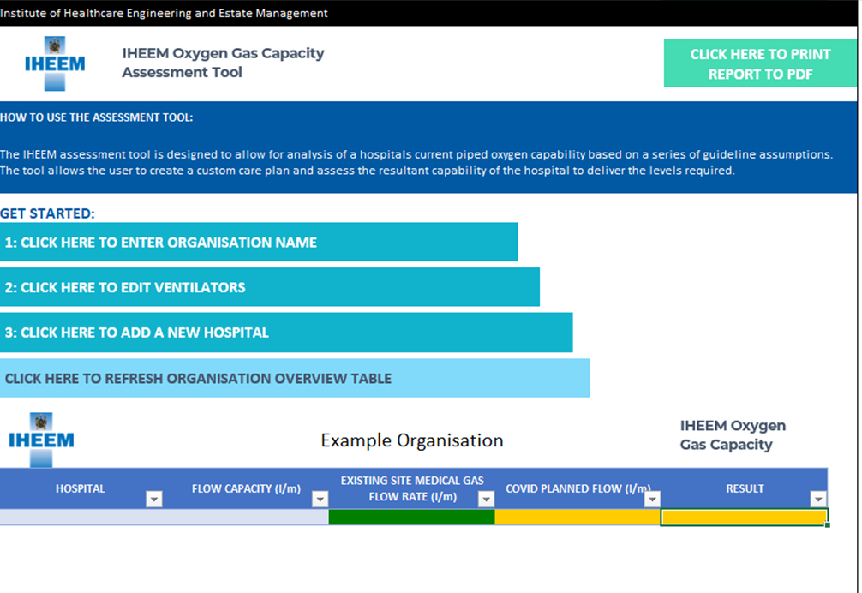
STEP 1: The start point is to set the Trust/ Health board or Health Organisation Name. To do this please click on the button labelled Organisation Name.

Once clicked a pop-up form (see below) will appear, here you will enter the organisation name - click SAVE to save the organisation name or CANCEL to leave the input form.
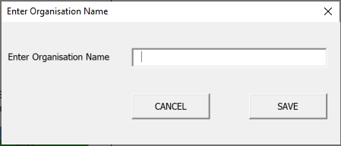

STEP 2: The assessment tool is preconfigured with 5 ventilator types namely. If your organisation uses a different type of ventilator, please click the button 2: Edit Ventilator. The included ventilator types are: O type patient (facemask), O+ type patient (Non-Invasive Ventilator), O+ type Venturi/ whispalite, High flow O2 driven CPAP NIV, V Type patient (intubated through a ventilator).

STEP 3: Within your organisation you may have several hospitals. This tool allows you to add all hospitals under your control and summarise them on the OVERVIEW table to give you clear insight based on the current situation and the modified care plan. To enter a new hospital please click on the button 3: Add new Hospital button on the overview page and the following form will appear.

Enter the Name of the Hospital, the Number of Beds, and the Maximum Evaporator Flow in litres per min (l/min).
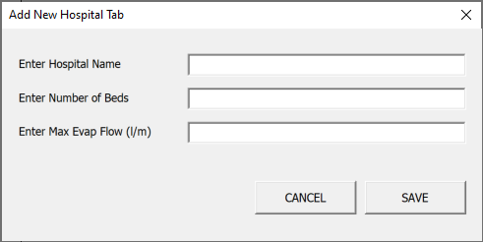

Click SAVE to save the new hospital and you will see an additional TAB created for the hospital next to the OVERVIEW tab of the worksheet.

Each new hospital will have its own analysis Tab created. Each tab layout is the same and shows two graphs. The Left graph shows the hospitals current position based on the details entered previously and based on the industry guidelines.
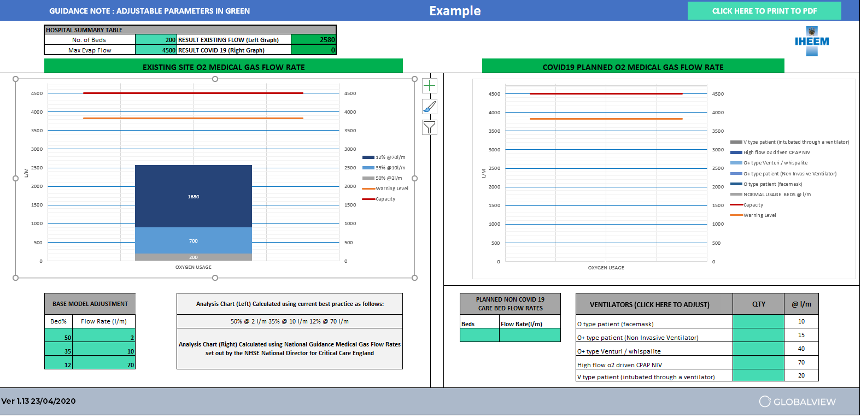
The Right Graph allows you to add any additional ventilators required due to COVID 19 and enable a modification of the care plan to suit your specific hospital. This can be done by adjusting the numbers within the light green boxes on the form.
NOTE: The ORANGE Line on the graphs represents the Warning level for the hospital set at 85% of Max Evap Flow.
NOTE: The RED line on the graphs represents the maximum capacity of the piped gas system of the hospital.

The LEFT graph is calculated using best practice assumptions and can be adjusted to suit the base care model for the hospital. This is circled in orange in the image below.
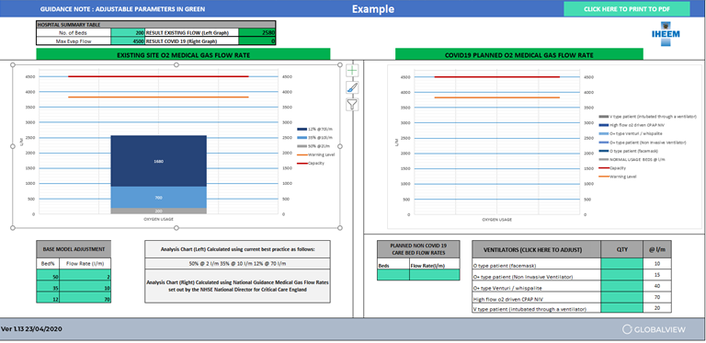
The RIGHT graph is free to model the hospitals potential COVID-19 care model and consists of a PLANNED NON-COVID 19 BED FLOW RATE table and a VENTILATORS table circled below:
Begin by entering the Planned Non COVID 19 bed flow rates into the model. This sets the NORMAL USAGE BEDS figure in l/m for the analysis. The ventilators can then be added depending on the type and the l/m flow rates. In doing this you will see that the Right-hand side graph starts to reflect your decisions and you can assess if you are approaching the warning level criteria within the tool.

The warnings are traffic light base indicating Green for OK, Amber for Warning and Red for Critical. These can be seen via the HOSPITAL SUMMARY TABLE (results existing flow (Left Graph) cell and Result COVID-19 (Right Graph) cell) as well as the changes to the graph titles as shown below:

Organisation Result Check
The tool will summarise the results of all hospitals within the organisation into a simple table. The table is found on the OVERVIEW tab within the workbook.
Simply Click on the PRODUCE ORGANISATION OVERVIEW TABLE as shown below to update/refresh the table.

Print Results
The results can be printed either per record (within each hospitals summary tab (top right-hand corner) or via the main OVERVIEW tab within the workbook. Simply Click on the PRINT REPORT TO PDF button to print the summary table and each hospital data in a single report.

