www.iheem.org.uk Version 1.0 April 2020
IHEEM Simple Gas Cylinder Monitoring Tool
DISCLAIMER: This information and template is provided for guidance purposes only to assist in these unprecedented Covid-19 requirements and should not be regarded as a substitute for normal good working practice, local regulations, and advice. You should not rely upon the information as your only basis for making business, legal or other decisions. Any reliance you place on such material is at your own risk. ____________________________________________________________________________________________________
About the Tool
The cylinder monitor tool is designed to allow for monitoring and analysis of a hospitals cylinder gas usage. The tool allows the user to check the current stock levels and to set thresholds for the minimum number of each cylinder type required. Plus, week-on-week usage based on the increased COVID-19 requirements.
How the Tool Works
The Tool comprises of a DASHBOARD and LOG tab located at the bottom of this workbook:
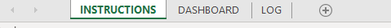

To start please click on the DASHBOARD Tab.
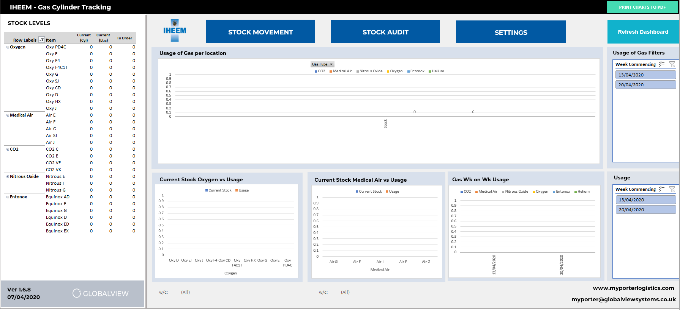
STEP 1: The start point is to set your cylinder types, volume, ideal stock level and Locations. To do this please click on the button labelled SETTINGS.

Once clicked a pop- up form (see below) will appear, here you will select Edit Locations.
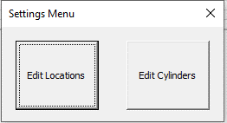

Once clicked a pop-up form (see below) will appear, here you will enter the main departments and wards around your hospital where gas is used - once complete click CLOSE to save and leave the input form.
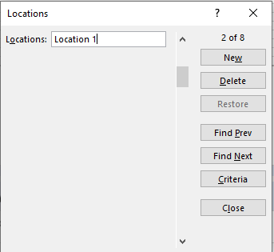

Then click the SETTINGS button again, once clicked a pop-up form (see below) will appear, here you will select Edit Cylinders.

Once clicked a pop up form (see below) will appear, here you will enter main gas cylinders that your hospital use - Start with entering the Cylinder Type, Capacity in Litres, Ideal Stock Capacity and Gas Type. The main gas types and sizes are already populated. Once complete click CLOSE to save and leave the input form.
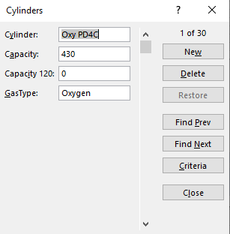

STEP 2: Now enter your current stock levels. Click the Stock Audit button.

Once clicked a pop-up form (see below) will appear, here you will enter the current stock levels of each cylinder, scrolling between each - once complete click CLOSE to save and leave the input form.
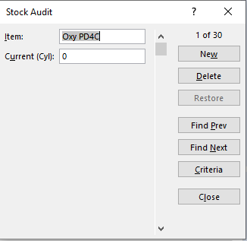

Once back to the main dashboard click the refresh button. Now the left column will be completed.

STEP 3: The tool is now ready to use. Once a Cylinder Gas is taken to a ward or department this can be updated by selecting the STOCK MOVEMENT button.

Once clicked a pop up form (see below) will appear, here you will select gas types from the drop down, the location where the cylinder is going and the quantity - once complete click SAVE to save and EXIT to leave the input form.
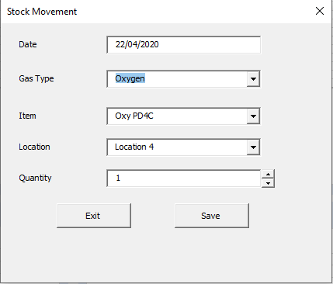
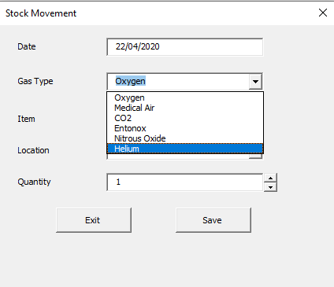

New stock levels are input by clicking on the Stock Audit button

MAIN DASHBOARD
Graphs and tables automatically update following stock movement and audits. The date range for the graph can be selected on the right tab. Individual weeks can be selected to be shown or multiple weeks by selecting the top clipboard icon. Gas types can be selected or deselected to be shown on the graph also.
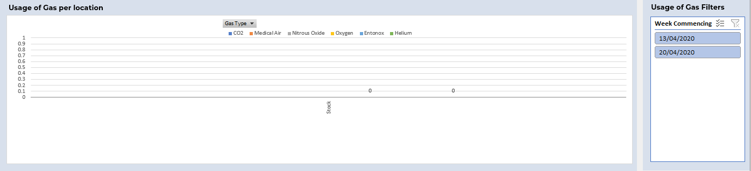

Date range for the graphs can be selected on the right tab. Individual weeks can be selected or multiple weeks by selecting the top clipboard icon. This will be shown on all three graphs along the bottom row.
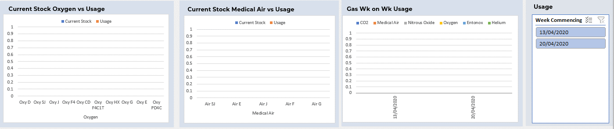

Table shows current number of Cylinders, Number of Litres and number of cylinders to arrive back at ideal stock levels.
PRINT RESULTS
The graphs can be printed simply Click on the PRINT REPORT TO PDF button in the top right corner. This will print as per the current selections.

