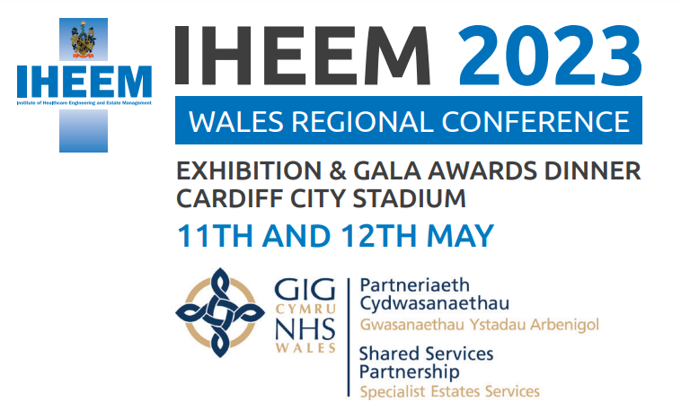

Exhibitor Booking Form
Company Name
Exhibitor Package Required | Bronze
Please complete the below details for the individual managing the booking

Title
First Name
Surname
Job Title
Email address (Please use the one you are known to us as where applicable)
Telephone Number
Please select your ticket type | Day 1  Day 2  Both Days  Day 1 including Gala Dinner  Day 2 including Gala Dinner  Both Days including Gala Dinner  Dinner Only  Not attending lead contact only
Let us know of any access requirements (leave blank if none)
Let us know of any dietary requirements (leave blank if none)
Membership number
Address

Please Provide the billing/invoicing address if different from the below

Billing address

Included in your package are 2 exhibitor passes, these entitle 2 named individuals entry to both days of the conference, attendance at the pre-dinner drinks reception and a place at the Gala Awards dinner. Both the pre-dinner drinks reception and the Gala dinner are being held at the Coal Exchange Hotel, Cardiff Bay, on the evening on the 11th May 2023.
Your may add more names, if so, these will be charged at the IHEEM members rate for attendance at the conference and the full rate for the dinner.

Details of those attending on behalf of the exhibitor

Name | Email | Access requirements | Dietary requirements

Signed
Date

