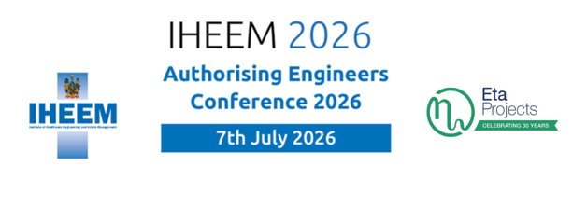

Exhibitor Booking Form
Company Name
Exhibitor Package Required
Please complete the below details for the individual managing the booking

Title
First Name
Surname
Job Title
Email address (Please use the one you are known to us as where applicable)
Telephone Number
Please select your ticket type
Let us know of any access requirements (leave blank if none)
Let us know of any dietary requirements (leave blank if none)
Membership number
Address

Please Provide the billing/invoicing address if different from the below

Billing address

Included in your package at a cost of £1,600 plus vat is 2 exhibitor passes, these entitle 2 named individuals entry to the conference, and attendance at the pre-event dinner on 7th July 2026 being held in the Board room overlooking Epsom racecourse.
You may add more names, if so, these will be charged at the IHEEM members rate £75 plus vat for attendance at the conference and £85 plus vat for attendance at the pre-event dinner.

Details of those attending on behalf of the exhibitor

Name | Email | Access requirements | Dietary requirements

Please return the form to events@iheem.org.uk

Signed
Date

